



**Experiment (2)**

**Systems Properties and Convolution**

1) Linearity and time invariance:

| **Name:** Norhan Reda Abd El-wahed Ahmed | **Sec:2** | **B. N:30** |
| --- | --- | --- |

**Experiment 2 –Part 1 Results sheet:**

1- Analytical solution to discover time invariance and linearity of the systems:

a)

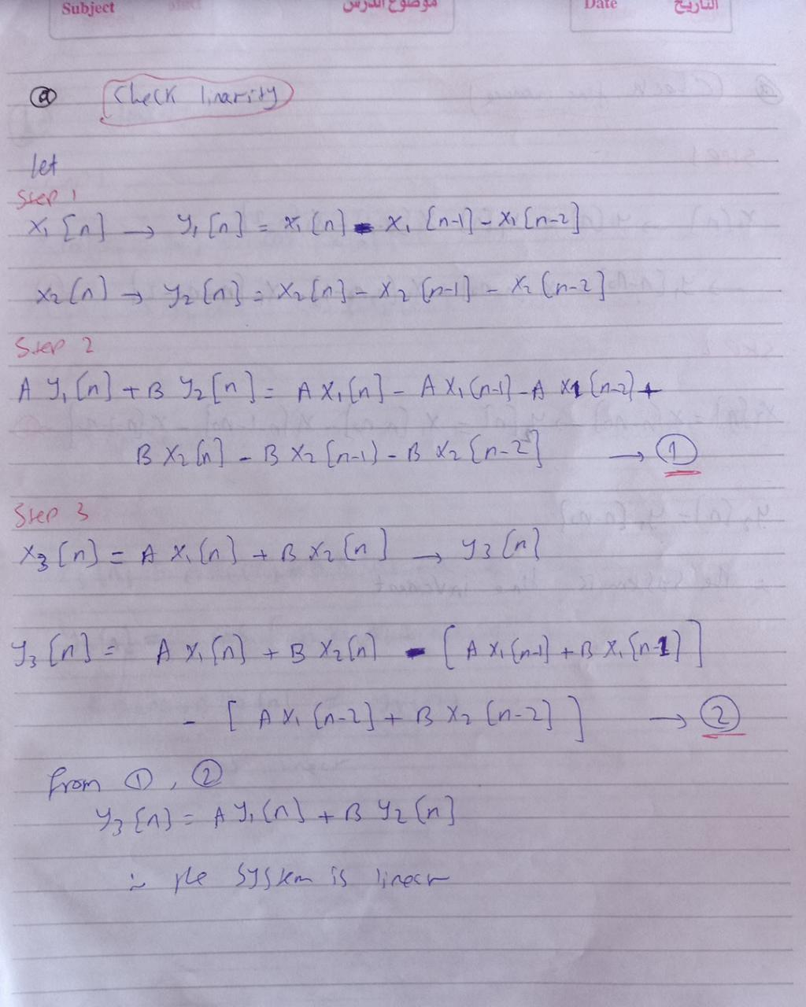

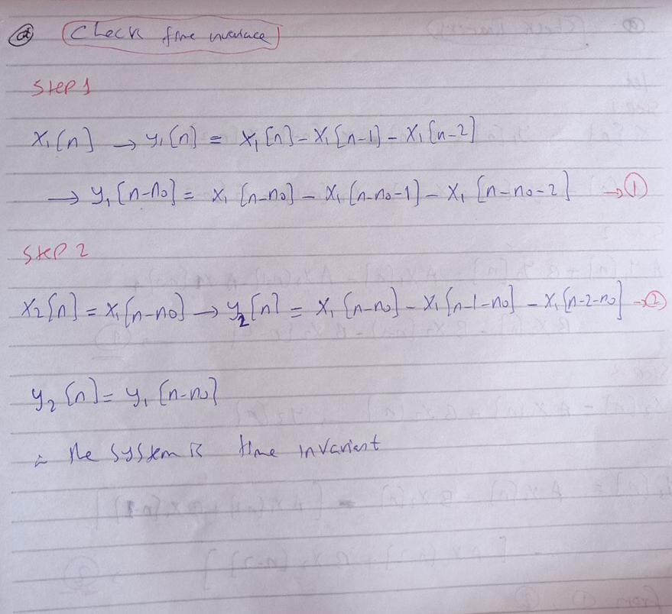

b)

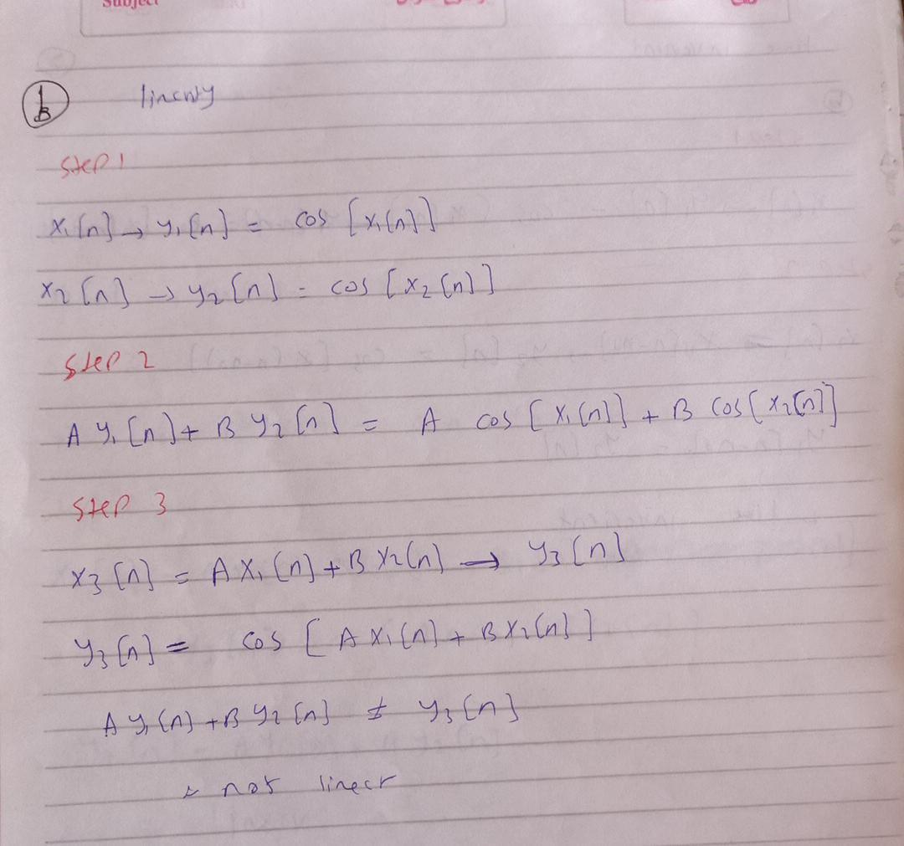

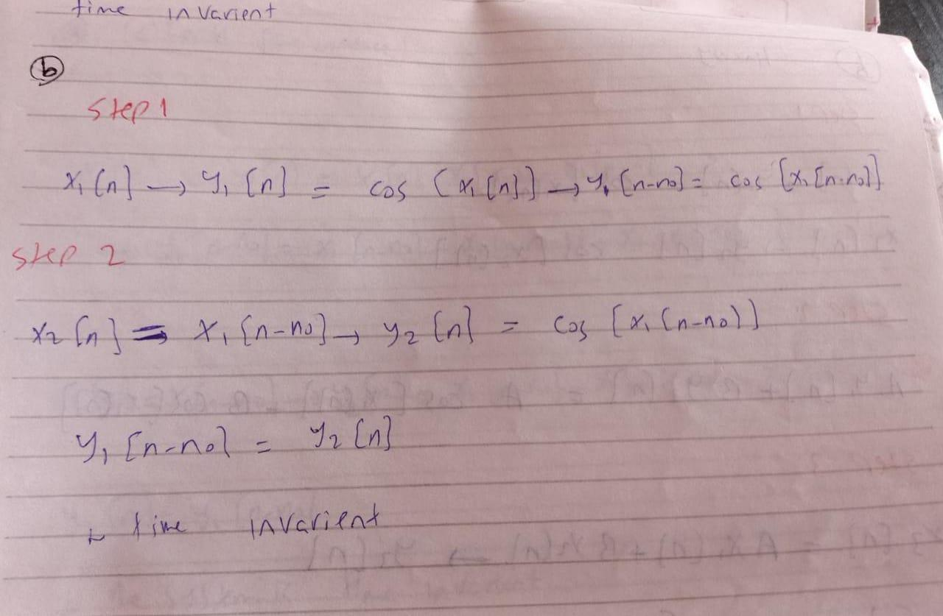

c)

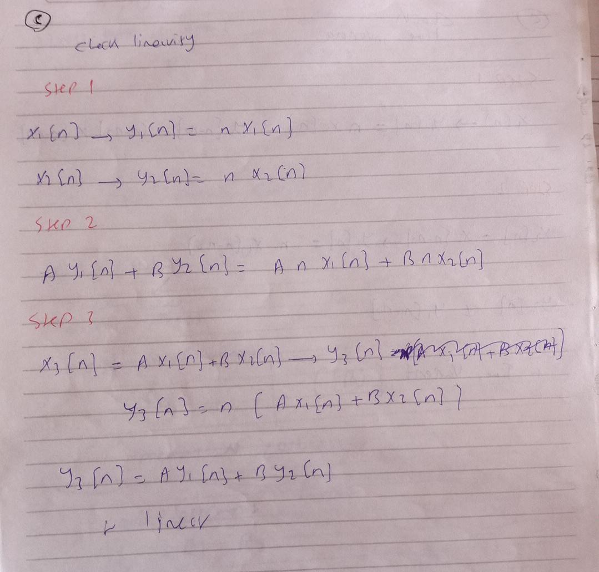

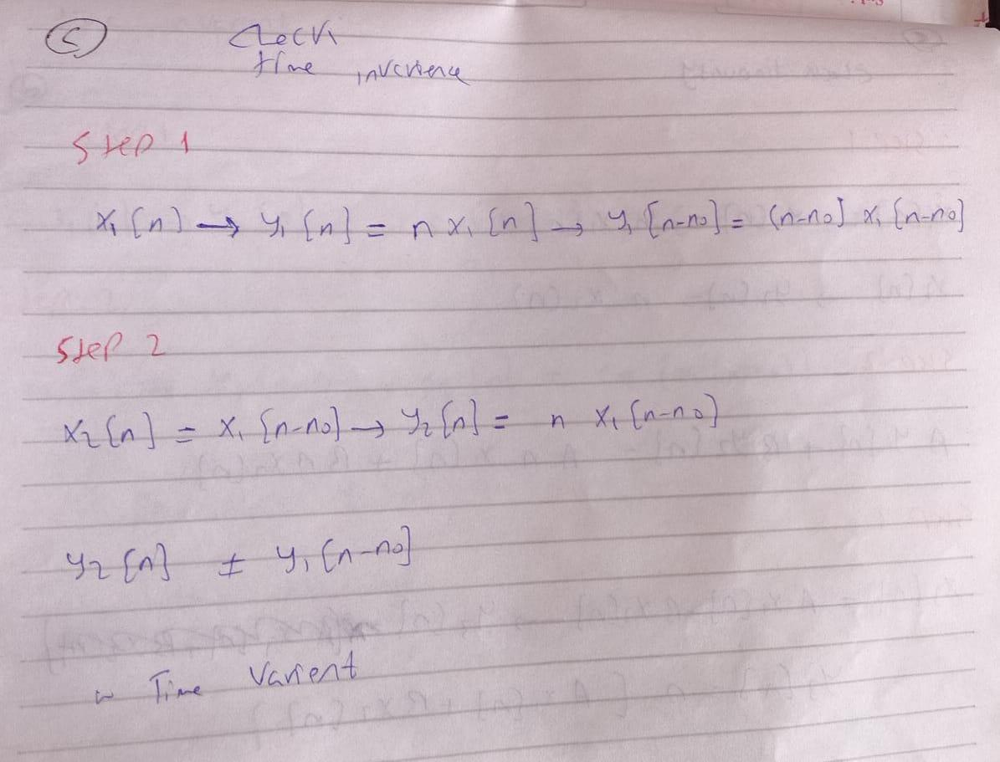

Write the code used to input the first signal to the three systems

| Code | System |
| --- | --- |
| Input 1  n1=[-10:10];  x1=[zeros(1,10) 1 zeros(1,10)];  x2=[zeros(1,11) 1 zeros(1,9)];  x3=[zeros(1,12) 1 zeros(1,8)];  y=x1-x2-x3;  stem(n1,y);  input 2  n2=[-9:11];  x1=[zeros(1,10) 1 zeros(1,10)];  x2=[zeros(1,11) 1 zeros(1,9)];  x3=[zeros(1,12) 1 zeros(1,8)];  y=x1-x2-x3;  stem(n2,y);  input3  n=[-10:10];  x1=[zeros(1,10) 1 zeros(1,10)];  x2=[zeros(1,11) 1 zeros(1,9)];  x3=[zeros(1,12) 1 zeros(1,8)];  x11=[zeros(1,11) 1 zeros(1,9)];  x22=[zeros(1,12) 1 zeros(1,8)];  x33=[zeros(1,13) 1 zeros(1,7)];  y=(x1+2.*x11)-(x2+2.*x22)-(x3+2.*x33);  stem(n,y); | a |
| Input 1  n=[-10:10];  x=[zeros(1,10) 1 zeros(1,10)];  y= cos(x);  stem(n,y);  input 2  n=[-9:11];  x=[zeros(1,10) 1 zeros(1,10)];  y= cos(x);  stem(n,y);  input3  n=[-10:10];  x1=[zeros(1,10) 1 zeros(1,10)];  x2=[zeros(1,11) 1 zeros(1,9)];  y= cos(x1+2.*x2);  stem(n,y); | b |
| Input 1  n=[-10:10];  x=[zeros(1,10) 1 zeros(1,10)];  y= n.*x;  stem(n,y);  input 2  n=[-9:11];  x=[zeros(1,10) 1 zeros(1,10)];  y= n.*x;  stem(n,y);  input3  n=[-10:10];  x1=[zeros(1,10) 1 zeros(1,10)];  x2=[zeros(1,11) 1 zeros(1,9)];  y= n.*(x1+2.*x2);  stem(n,y); | c |

Plotting for the responses of the systems to the three inputs:

| System (3) | System (2) | System (1) |  |
| --- | --- | --- | --- |
|  |  |  | Input(1) |
|  |  |  | Input(2) |
|  |  |  | Input(3) |
| Linear : when multiplying inputs by factors and adding them output is also multiplied and added  not time invariant: when shifting input output is not shifted version from original output | Not linear : when multiplying inputs by factors and adding them output is not multiplied and added  time invariant: when shifting input output is also the same but shifted | Linear: when multiplying inputs by factors and adding them output is also multiplied and added  time invariant :when shifting input output is also the same but shifted | Comment |

Part 2:

1) Discrete time convolution:

| **Name:** Norhan Reda Abd El-wahed Ahmed | **Sec:2** | **B. N:30** |
| --- | --- | --- |

**Experiment 2- Part 2 Results sheet:**

a) Convolution complete code (1)

**nx=[-3 -2 -1];**

**x =[1 2 3];**

**nh=[-6 -5 -4 -3 -2 -1];**

**h =[9 8 5 32 5 3];**

**M=length(x);**

**N=length(h);**

**ny=** nx(1)+nh(1):nx(end)+nh(end);

**y=zeros(1,length(ny));**

**for u=1:length(h)**

**x1=h(u)*[zeros(1,u-1) x zeros(1,N-u)];**

**y=y+x1;**

**end**

**stem(ny,y);**

Using stem function to plot the final output y.

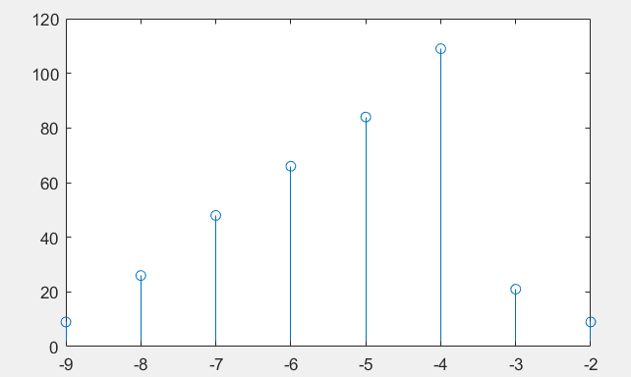

b) The conv command:

nx=[-3 -2 -1];

x =[1 2 3];

nh=[-6 -5 -4 -3 -2 -1];

h =[9 8 5 32 5 3];

>> y=conv(x,h);

>> n_c= nx(1)+nh(1):nx(end)+nh(end);

>> stem(n_c,y);

Using stem function to plot its final output y.

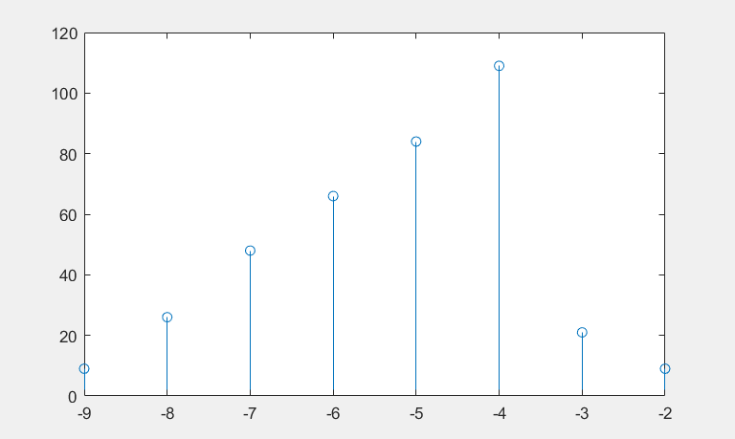

2) Fourier Series:

**Experiment 2 Results sheet:**

| **N=length(a);**  **n=0:N-1;**  **for k=0:N-1**  **x(k+1)=sum(a.*exp(2*pi*i*k*n/N));**  end | a)Inverse Fourier Series Code |
| --- | --- |
| a-  [2.500000000000000 + 0.000000000000000i,  -0.500000000000000 + 0.500000000000000i,  -0.500000000000000 - 0.000000000000000i,  -0.500000000000000 - 0.500000000000000i] | b)Fourier series of the three signals: |
| b-  [1.500000000000000 + 0.000000000000000i,  -0.250000000000000 -0.250000000000000i,  0.000000000000000e+00 - 3.061616997868382e-17i,  -0.250000000000000 + 0.250000000000000i] |
| c-  [0.000000000000000 + 0.000000000000000i,  0.000000000000000 - 0.850650808352040i,  -0.000000000000000 + 0.525731112119134i,  0.000000000000000 - 0.525731112119134i,  -0.000000000000000 + 0.850650808352040i]  Code  **N=length(x);**  **n=0:N-1;**  **for k=0:N-1**  **a(k+1)=1/N*sum(x.*exp(-2*pi*i*k*n/N));**  end |
| [1.000000000000000 - 0.000000000000001i,  2.000000000000000 - 0.000000000000000i,  3.000000000000000 - 0.000000000000000i,  4.000000000000000 + 0.000000000000000i] | X signal for the previous Fourier series coefficients |
| [1.000000000000000 - 0.000000000000000i,  2.000000000000000 - 0.000000000000000i,  2.000000000000000 + 0.000000000000000i,  1.000000000000000 + 0.000000000000000i] |
| [-2.331468351712829e-16 + 1.110223024625157e-16i,  1.000000000000000 + 0.000000000000000i,  2.000000000000000 + 0.000000000000000i,  -2.000000000000000 + 0.000000000000000i,  -1.000000000000000 + 0.000000000000000i] |

|  | c) analytical solution of the three signals: |
| --- | --- |
|  |
|  |
| a-  A=  [2.061842760018148e-16 + 0.000000000000000e+00i,  -4.758098676964956e-17 + 2.061842760018148e-16i,  -1.704985359245776e-16 - 1.427429603089487e-16i,  0.500000000000000 - 0.000000000000000i,  0.500000000000000 + 0.000000000000001i,  -8.326672684688674e-16 + 4.758098676964956e-17i,  1.903239470785983e-16 - 3.806478941571965e-16i]  A0=0 , A1=0 , A2=0 , A3=0.5 , A4=0.5 , A5=0, A6=0  Code  n=[ 0 ,1,2,3,4,5,6 ];  x=cos(2*pi*n*3/7);  N=length(x);  n=0:N-1;  for k=0:N-1  a(k+1)=1/N*sum(x.*exp(-2*pi*i*k*n/N));  end | Simulation output  of the three signals: |
| b-  A=  [-8.723180907769087e-17 + 0.000000000000000e+00i,  7.137148015447434e-17 - 1.506731247705569e-16i,  1.962715704248045e-16 + 1.110223024625157e-16i,  0.000000000000000 - 0.500000000000000i,  -0.000000000000000 + 0.500000000000000i,  2.101493582326189e-16 + 1.586032892321652e-17i,  4.599495387732791e-16 + 2.379049338482478e-17i]  A0=0 , A1=0 ,A2=0 ,A3=-0.5j , A4=0.5j, A5=0, A6=0    code  n=[ 0 ,1,2,3,4,5,6 ];  x= sin(2*pi*n*3/7);  N=length(x);  n=0:N-1;  for k=0:N-1  a(k+1)=1/N*sum(x.*exp(-2*pi*i*k*n/N));  end |
| c-  A=  [2.061842760018148e-16 - 8.723180907769087e-17i,  8.723180907769087e-17 + 2.696255916946809e-16i,  -2.696255916946809e-16 + 9.516197353929913e-17i,  1.000000000000000 + 0.000000000000000i,  1.586032892321652e-16 + 7.930164461608260e-17i,  -8.326672684688674e-16 + 2.537652627714643e-16i,  1.744636181553817e-16 + 7.930164461608260e-17i]  A0=0 , A1=0 , A2=0 , A3=1, A4=0, A5=0, A6=0  code  n=[ 0 ,1,2,3,4,5,6 ];  x= exp(j*2*pi*n*3/7);  N=length(x);  n=0:N-1;  for k=0:N-1  a(k+1)=1/N*sum(x.*exp(-2*pi*i*k*n/N));  end |

**Codes**

1) Linearity and time invariance:

**Experiment 2 –Part 1 Results sheet:**

-a

Input 1

n1=[-10:10];

x1=[zeros(1,10) 1 zeros(1,10)];

x2=[zeros(1,11) 1 zeros(1,9)];

x3=[zeros(1,12) 1 zeros(1,8)];

y=x1-x2-x3;

stem(n1,y);

input 2

n2=[-9:11];

x1=[zeros(1,10) 1 zeros(1,10)];

x2=[zeros(1,11) 1 zeros(1,9)];

x3=[zeros(1,12) 1 zeros(1,8)];

y=x1-x2-x3;

stem(n2,y);

input3

n=[-10:10];

x1=[zeros(1,10) 1 zeros(1,10)];

x2=[zeros(1,11) 1 zeros(1,9)];

x3=[zeros(1,12) 1 zeros(1,8)];

x11=[zeros(1,11) 1 zeros(1,9)];

x22=[zeros(1,12) 1 zeros(1,8)];

x33=[zeros(1,13) 1 zeros(1,7)];

y=(x1+2.*x11)-(x2+2.*x22)-(x3+2.*x33);

stem(n,y);

b-

Input 1

n=[-10:10];

x=[zeros(1,10) 1 zeros(1,10)];

y= cos(x);

stem(n,y);

input 2

n=[-9:11];

x=[zeros(1,10) 1 zeros(1,10)];

y= cos(x);

stem(n,y);

input3

n=[-10:10];

x1=[zeros(1,10) 1 zeros(1,10)];

x2=[zeros(1,11) 1 zeros(1,9)];

y= cos(x1+2.*x2);

stem(n,y);

c-

Input 1

n=[-10:10];

x=[zeros(1,10) 1 zeros(1,10)];

y= n.*x;

stem(n,y);

input 2

n=[-9:11];

x=[zeros(1,10) 1 zeros(1,10)];

y= n.*x;

stem(n,y);

input3

n=[-10:10];

x1=[zeros(1,10) 1 zeros(1,10)];

x2=[zeros(1,11) 1 zeros(1,9)];

y= n.*(x1+2.*x2);

stem(n,y);

**Experiment 2- Part 2 Results sheet:**

a-

**nx=[-3 -2 -1];**

**x =[1 2 3];**

**nh=[-6 -5 -4 -3 -2 -1];**

**h =[9 8 5 32 5 3];**

**M=length(x);**

**N=length(h);**

**ny=** nx(1)+nh(1):nx(end)+nh(end);

**y=zeros(1,length(ny));**

**for u=1:length(h)**

**x1=h(u)*[zeros(1,u-1) x zeros(1,N-u)];**

**y=y+x1;**

**end**

**stem(ny,y);**

-b

nx=[-3 -2 -1];

x =[1 2 3];

nh=[-6 -5 -4 -3 -2 -1];

h =[9 8 5 32 5 3];

>> y=conv(x,h);

>> n_c= nx(1)+nh(1):nx(end)+nh(end);

>> stem(n_c,y);

2) Fourier Series:

***Students experiment 1:***

**-a**

**N=length(a);**

**n=0:N-1;**

**for k=0:N-1**

**x(k+1)=sum(a.*exp(2*pi*i*k*n/N));**

end

**-b**

-a

x=[1 2 3 4];

**N=length(x);**

**n=0:N-1;**

**for k=0:N-1**

**a(k+1)=1/N*sum(x.*exp(-2*pi*i*k*n/N));**

end

-b

x=[1 2 2 1]

**N=length(x);**

**n=0:N-1;**

**for k=0:N-1**

**a(k+1)=1/N*sum(x.*exp(-2*pi*i*k*n/N));**

end

-c

;x=[0 1 2 -2 -1]

**N=length(x);**

**n=0:N-1;**

**for k=0:N-1**

**a(k+1)=1/N*sum(x.*exp(-2*pi*i*k*n/N));**

end

**-c**

-a

n=[ 0 ,1,2,3,4,5,6 ];

x=cos(2*pi*n*3/7);

N=length(x);

n=0:N-1;

for k=0:N-1

a(k+1)=1/N*sum(x.*exp(-2*pi*i*k*n/N));

end

b-

n=[ 0 ,1,2,3,4,5,6 ];

x= sin(2*pi*n*3/7);

N=length(x);

n=0:N-1;

for k=0:N-1

a(k+1)=1/N*sum(x.*exp(-2*pi*i*k*n/N));

end

c-

n=[ 0 ,1,2,3,4,5,6 ];

x= exp(j*2*pi*n*3/7);

N=length(x);

n=0:N-1;

for k=0:N-1

a(k+1)=1/N*sum(x.*exp(-2*pi*i*k*n/N));

end